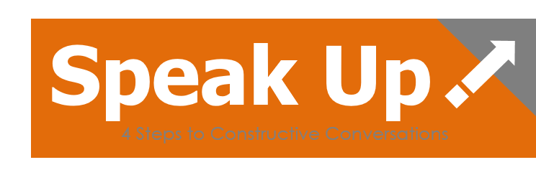

Most all of us would benefit from a greater ability to speak our mind.
Others of us say plenty, but in a manner that is difficult to receive.
In both cases, good intentions and valuable ideas get lost.

Speak Up! helps redirect both of these liabilities to create a more engaged and innovative work place. It offers a practical 4 step guide to building a communication culture based on a blend of authenticity & respect.
2 Companion Feedback Tools
(Both optional)
Speak Up! – 360©
Speak Up! – Team Report©
Workshop Options:
Speak Up! for Leaders
Speak Up! for Teams
Speak Up! for Departments

For Leaders, Teams, & Departments

Craft better solutions
Improve collaboration
Build a more engaged work environment

Contact: Bill@AdaptiveTeamLeadership.com / 919 961-2492

“The most important work in the new economy is creating conversations.”
– Alan Weber, Fast Company Magazine

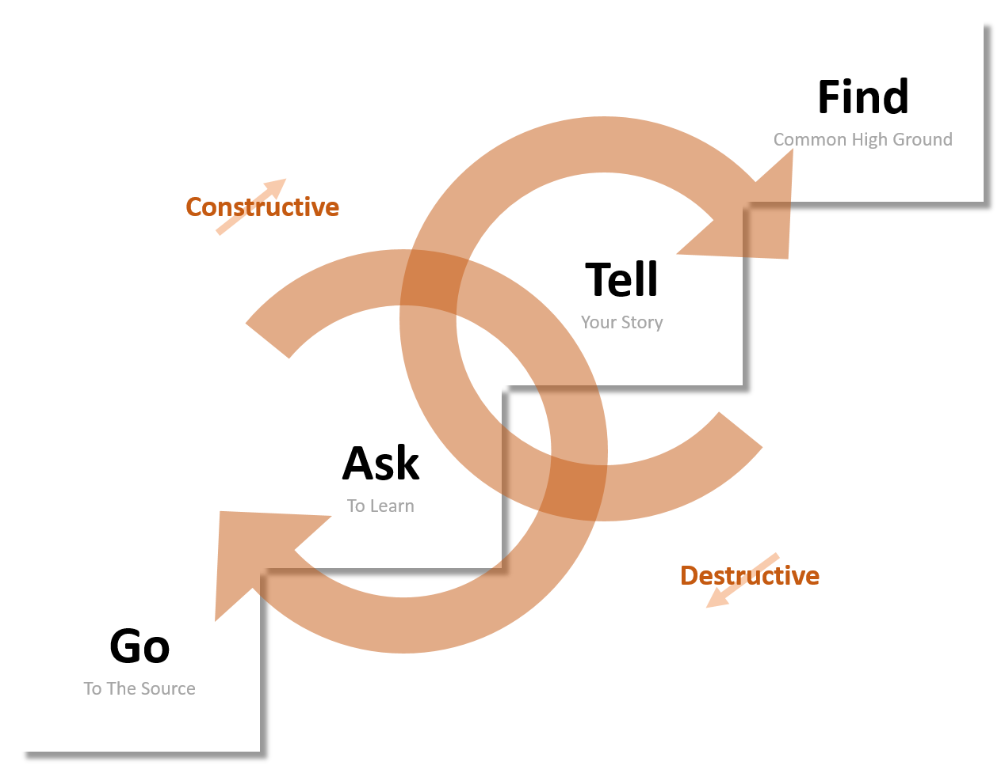
Highly Interactive
experiential exercises, analysis of feedback reports, small group interactions, action planning

Flexible Formats
Customizable for 2-hour, half day, or full day formats

Authors:
Bill Winfrey
Nancy Vigander Winfrey, PhD


Contact Bill - 919.961.2492
Bill@AdaptiveTeamLeadership.com
www.AdaptiveTeamLeadership.com

