DISC Behavioral Styles
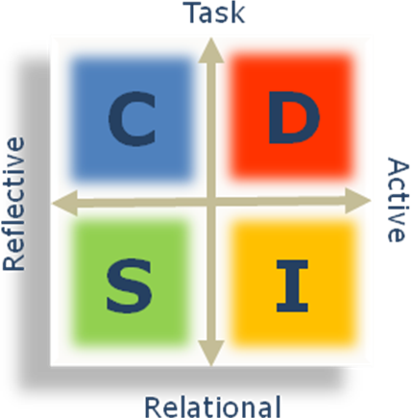

Would you like to better understand:
- how to capitalize on your strengths?
- how to minimize your liabilities?
- how to blend with contrasting styles?
- how to read & respond to individual needs?

DISC can get you there
DISC is the international language of behavior. Its worldwide popularity is due to one easy framework being a guide to understanding yourself, others, and situations. Its applications are many and varied.

1 Assessment… 2 Workshops
We offer DISC in 2 separate workshops that can either blend with each other or stand alone. The first is a personal development focus and the second is an interpersonal focus, both essential fundamental building blocks to long term effectiveness.

Workshop 1: DISCovering Work Styles (personal focus)
Gain a clear understanding of the 4 major work styles that people innately operate from. Learn their associated assets and liabilities. Find your greatest strengths and potential blind spots. Develop a plan to better match your style and current role.

Workshop 2: Adapting to Differing Styles (interpersonal focus)
Learn how to build more rapport with any style. Learn how to gain more trust from those with much different approaches. Learn to resolve conflict according to individual needs. Learn to read styles and respond to vastly different settings.

Workshop Details:
- Applicable to all levels, leaders or team members
- Participants receive a DISC Personal Behavioral Assessment & participant notebook
- Easy to administer: 20 min assessment response time.
- Flexible Formats:
- Lunch & Learns introduce key DISC insights
- Half-day workshops include personal reports and exercises that help integrate concepts
- Full-day workshops adds practice utilizing new key behaviors
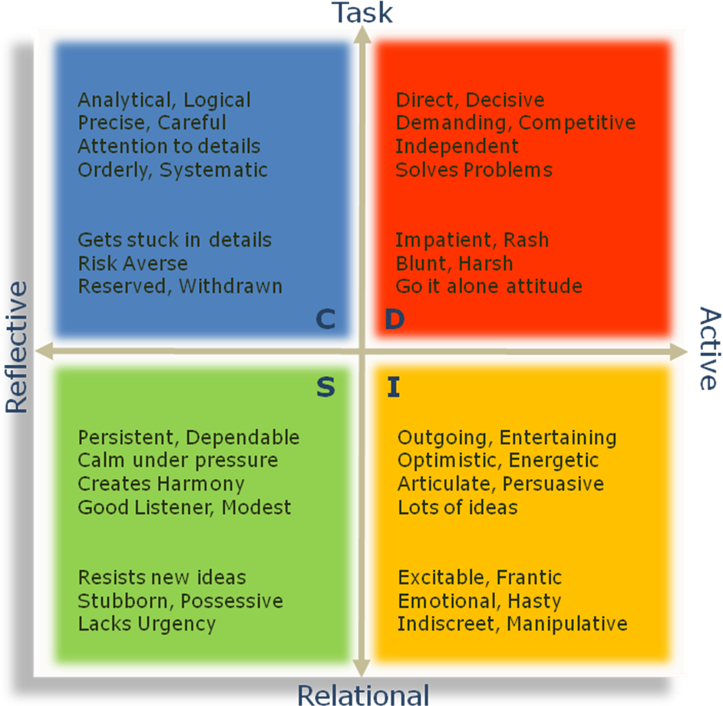
A DISC Styles Overview
There are no best styles, but there are best times to use or refrain from a certain behavior. Learning to better match your behavior to differing situations is a key to ongoing development and influence. That takes time and attention.

Dominance → Task Oriented Active
Influence → Relational Oriented Active
Steady → Relational Oriented Reflective
Conscientious → Task Oriented Reflective

Check out our Adaptive Team Leadership Series that builds upon the DISC framework
Contact
Bill Winfrey / 919.961.2492
Bill@AdaptiveTeamLeadership.com
www.AdaptiveTeamLeadership.com

