

Adaptive Leader – 360 ©

Feedback Tool & Workshop

Minor Adjustments. Major Impact.

How well balanced do others see your leadership?
Has your leadership style evolved in sync with your team?
What minor adjustments could have a major impact on your leadership success?
Identify Over & Under Use... Practical Development Guide... Track progress over time...

A significant liability for any leader is simply the Over Use of an otherwise valuable strength. This happens when a leader is unaware of when too much of a good thing is not such a good thing. Over and Under Uses is another term for inflexibility which is known to be a major cause of leadership derailment. A striking 80% of leaders are considered inflexible.

The AL-360© offers a rare and clear view of where and to what degree Over and Under Use occurs. This tool along with the Development Guide and follow up support… helps leaders pinpoint areas where adaptations will be most helpful in matching the current needs of the situation they lead. You’ll find these qualities and more:
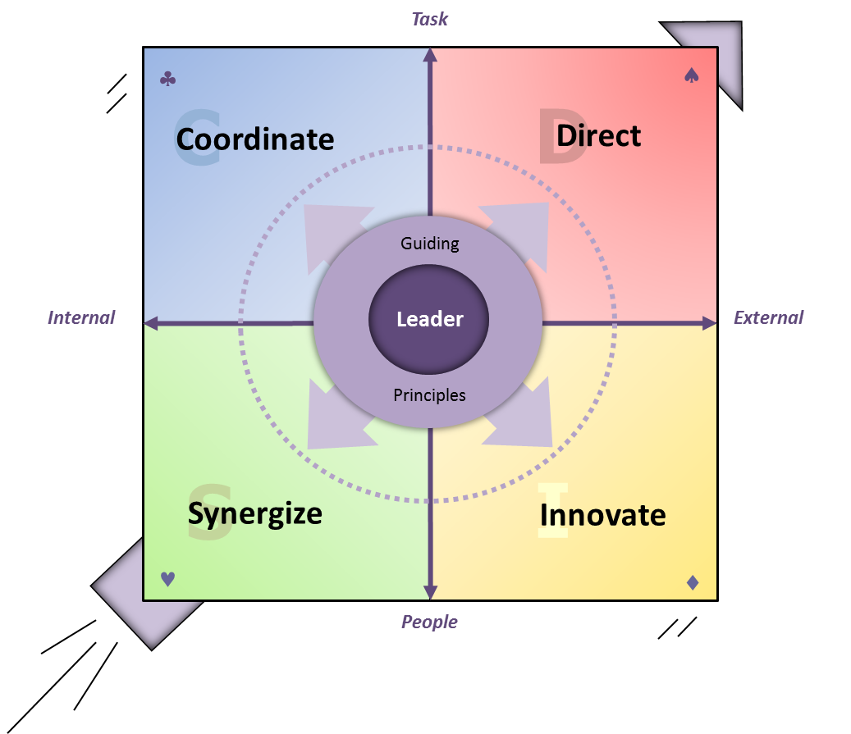
Winfrey Adaptive Team Leadership Model
© 2004-2014 Bill Winfrey
Simple & Insightful
- 4 Core Areas of Leadership Focus
- 6 pairs of Complementary Skill Sets

Reveals degree of Under & Over Use
- Quick online feedback process

Easy to Use
- Quick online feedback process
- Only 24 questions… ~ 15 min response

In-depth
- 20 page report with written comments
- Development Guide

Tracks Progress Over Time
- Targeted Re-Assessment at later date (included)
- No extra class time needed

One Suite
One Common Framework
The AL-360© is part of our uniquely integrated suite of tools that each stand alone or build upon the others. These tools include DISC, the Team Alignment Scorecard©, & the Organizational Alignment Scorecard©.

Flexible Formats
- Half Day – 2 Day Workshops
- Blends with and builds upon other modules

For leaders who:
- are mid to upper level
- were promoted because of subject expertise
- have led the same team over time and need to maintain

Contact: Bill Winfrey / 919.961.2492
Bill@AdaptiveTeamLeadership.com

