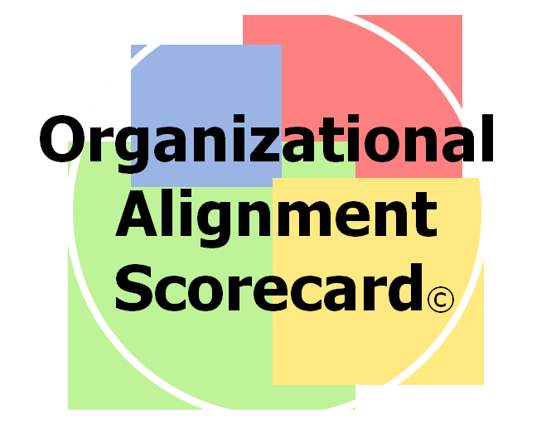

Feedback Tool & Workshop

What culture & values are driving your organization?

Are there imbalances that could impede or derail success?

What course adjustments would be most valuable now?

For Leadership Team Collaboration

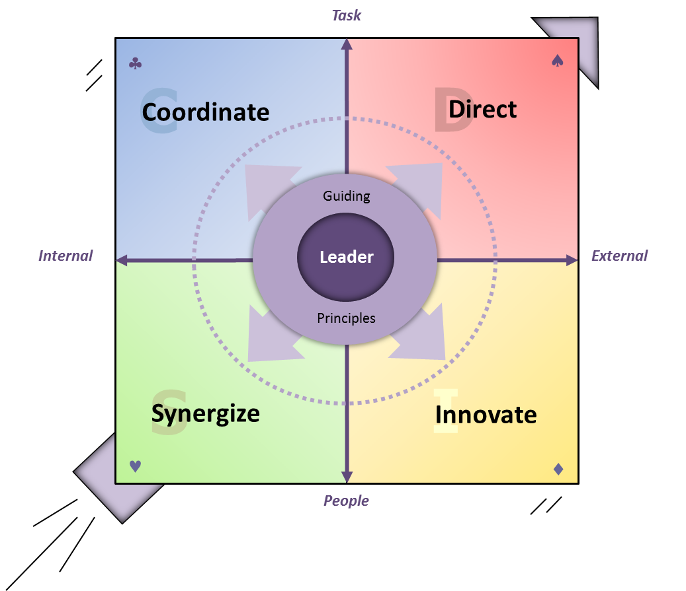
The OAS Workshop guides leadership teams in determining company direction and strategy. The feedback tool provides a company-wide view of its effectiveness in 4 competing values, which are each essential to long term success yet distinctly different from the others. Imbalances among these 4 areas will, in time, impede company growth. Your Leadership Team will have the benefit of current data that is clear and easy to understand. They will leave having agreed upon concerns and opportunities, and having established key next steps.
Winfrey Adaptive Team Leadership Model
© 2004-2014 Bill Winfrey

Quick Easy Online Feedback Collection…
- ~ 30 min response time
- 36 questions, written comments

A Simple Language for Organization Excellence…
- Intuitive, easy to understand
- 4 Competing but Core Organizational Needs

Develop Data-Driven Plans…
- Pinpoint and prioritize areas of focus
- Support your plans with concrete data

Flexible Format…
- Half Day to 2 Day team workshop or retreat
One Suite - One Common Framework
… a uniquely integrated suite of tools that each stand alone or build upon the others. These tools include DISC, the Team Alignment Scorecard ©, & The Adaptive Leader – 360©

- Enhanced with experiential or additional modules

Track Progress over time…
- 1 Current Feedback Report
- 1 Follow Up Reports (included)
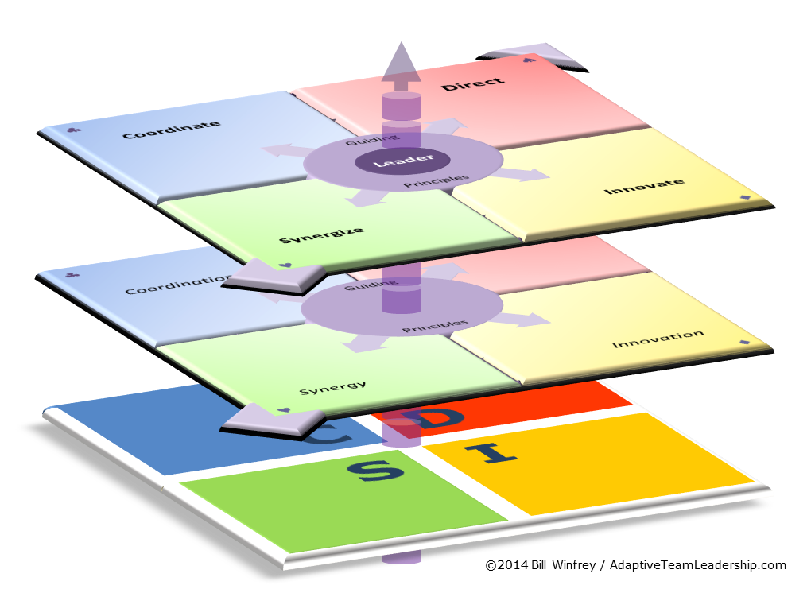
Uniquely Integrated Leadership Series…
- 1 Common Framework
- 5 key Levels of development

Adaptive Team
Leadership

